Instruction
Front  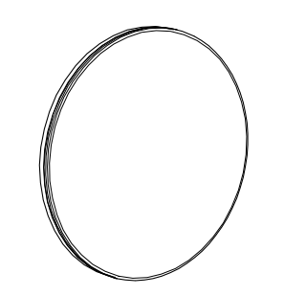 | Back  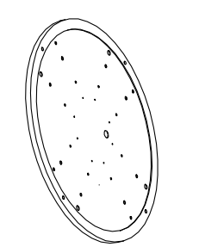 |  | Screws  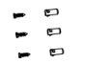
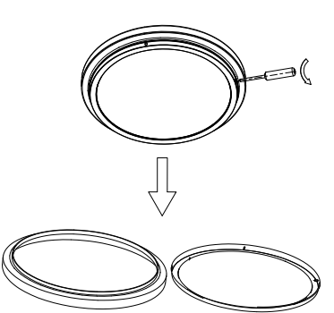  1，Remove the screws | 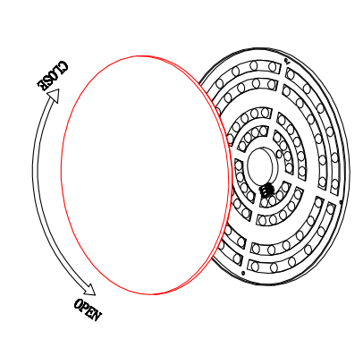  2，Put the cover leave from base |  | 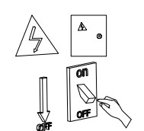  3，Cut off the electronic
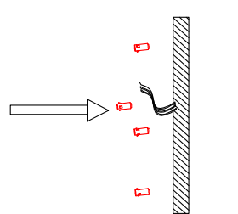  4，Install the Plastic expansion screw into the ceiling |  | 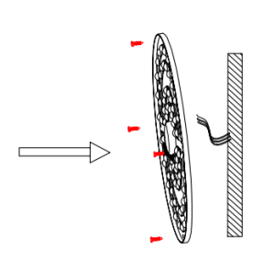  5，Screw through the base,install into the plastic expansion screw | 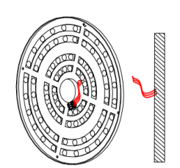  6，The wire from the ceiling passes through the hole of the lamp base and is connected to the wire of lamp
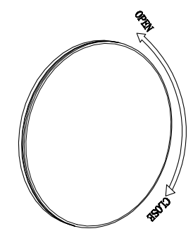  7，Install the cover |  | 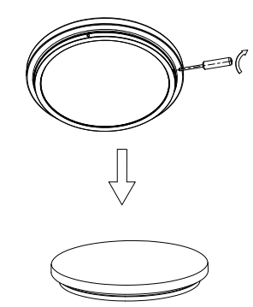  8，Comfirm it everything is okay | 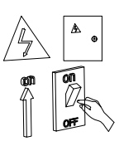  9，Turn on the electronic

